

|  |  |
| --- | --- |
| **Hands-on Exercise No. 3**  **DigiSkills**  **2.0 Batch-05 Freelancing** | **Total Marks: 10**  **Due Date: 24/08/2023** |

**STUDENT NAME:**

**Uzma Ejaz**

**Problem Statements:**

* **Create Services on freelance platforms.**
* **Increase your chances of getting orders without bidding.**
* **Increase earning potential.**

**Title for the profile: “**I willdevelop a premium business website with modern design/developing using WordPress”.

**Image for the Thumbnail:**

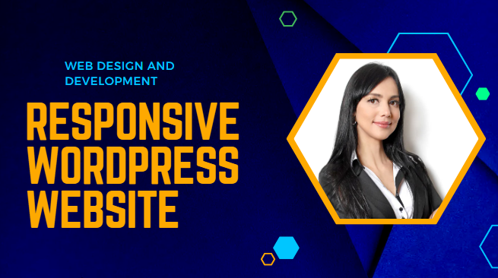

**Description for The Profile:**

Hi, I'm as a professional web designer and developer, I am dedicated to building smooth and functional websites. I specialize in all things WordPress, including customizations and theme development. With my expertise, you can expect a clean, unique, and professional website that will enhance your online business. Don't wait any longer! You've come to the right place for a WordPress designer and developer with plenty of experience in creating beautiful designs to turn your dream into reality.

A seasoned developer running a successful digital agency and focused on providing reliable solutions which can yield best results in given circumstances and move you closer to your goals. Whether it is WordPress, Custom Coding, or Front-End Design, I would love to help. I focus on listening and understanding exactly what you need and aim at producing results which can bring long-term benefits for your business.

**Relevant Taglines/Keywords:**

* WordPress,
* WordPress website design,
* WordPress website developing,
* WordPress plugin,
* WordPress SEO.

**Increase earning potential:**

**Packages:**

|  |  |  |
| --- | --- | --- |
| **Basic** | **Standard** | **Premium** |
| **$5** | **$10** | **$30** |
| **3 PAGES** | **4 TO 6 PAGES** | **7 TO 10 PAGES** |
| I Will Install WordPress and WordPress Theme with Small website. Fully responsive | I Will Install WordPress and WordPress Theme, Live Chat configuration, payment integration. | Install WordPress and Theme, Live Chat configuration, payment integration and more... |